Facebook Marketing

Facebook allows you to laser target people directly interested in what you have to offer as an Isochiral affiliate.

Savvy affiliate marketers are making as much as 5 figures a week by:

- Creating a Facebook community around a keyword, hobby or interest,

- Nurturing the community with relevant and personable content,

- Leveraging social proof, viral interaction & sharing through users' news feeds to organically attract more targeted users to the community.

The glue that holds your Facebook community together is the Like button, which automagically spreads your community -- with your Isochiral affiliate link -- through the busy, interactive and responsive Facebook platform.

Here are the four steps to selling Isochiral as an affiliate through Facebook:

- Choose a niche related to relaxation, meditation, yoga, entrepreneur etc
- Create a Facebook page for your niche and attract a community
- Nurture your community by providing relevant content
- Monetize the community by posting your Isochiral affiliate link
Define Your Niche
The first step to creating a Facebook community is to define the niche you are targeting within the Isochiral market. There are several niches Isochiral serves.

The main ones are:

- Meditation
- Relaxation / Anxiety / De-stress
- Yoga
- Tai Chi
- Hypnosis
- Personal Development
- Entrepreneur / Business achievement
- Reiki

Pick one of these close to your interests. Maybe your own keyword research has uncovered one particular niche worth exploring further.

Create Your Facebook Page
Creating a Facebook page around your niche allows you to monetize qualified traffic by engaging them in areas that touch on their interests.

To create a Facebook page around an Isochiral niche, go to this link:

http://www.facebook.com/pages/create.php

You want to create a community, so click Cause or Community:

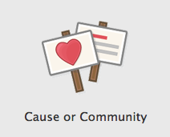

Enter your chosen Isochiral niche, and click Get Started:
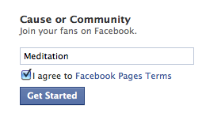

Keep your page name descriptive and brief. The name you enter will appear as your Facebook URL. If you enter Deep Meditation or Beach Yoga, your page will appear as

facebook.com/deepmeditation

facebook.com/beachyoga

Get People To Your Page
You've got to start somewhere, so start with your friends by sending personal messages through Facebook, asking them to Like your new page.

Also, search for your niche in the Facebook search box, to find other pages related to your own freshly minted piece of Facebook real estate. Commenting on the posts and updates that appear on these other pages will spread your page link to a targeted audience. Soon you'll see people interacting with your posts, which will bring them back to your page.

Add content
An engaging Facebook page will be shared across the network, multiplying the power of your content and bringing traffic back to your page. Offer personality, fun and something different so your page fans keep coming back, and interacting with your page.

- Facebook traffic loves images and videos! Links to YouTube on Isochiral niches like relaxation, at-home hypnosis, Reiki, tai chi, brainwave entrainment, will be shared by your community much more often than simple text updates.

- Increase clicks to your affiliate link by providing content that is personable and conversational. Links to interesting, relevant pages outside of Facebook -- an online news item, perhaps -- are a way to encourage comments and Likes. A rule of thumb is to post four on-topic, conversational threads for every promotional link.

Here are two examples of content-rich Meditation pages:

http://www.facebook.com/pages/Meditation/179187571898
http://www.facebook.com/pages/Meditation/150940074944308

Notice how these pages:
- Interact with users through a lot of relevant links. The page owner is nurturing the community, the page fans interact with the content, and the page spreads throughout the Facebook platform.

- Provide on-topic content that's posted as a conversation, not a company; a friend rather than a brand. Companies obsess about message and creating perfectly tailored content. Fans interact overwhelmingly with short and brisk content. Over a year of Facebook research for big brands including Starbucks and Buffalo Wild Wings, content with 10 words or less attracted 76% more interactions compared with content of 11 words or more.

- The content's written tone is speaking directly to the audience demographic (considerations such as age, gender, income, spouse etc). 61% of Facebook users are over 35, predominantly the same age group as Isochiral customers. You don't need to be a copywriting whizz to create funny or quirky comments that will be shared; just be yourself.

Advertising
Once you've gained traction through Facebook traffic interested in your niche, you can increase your page Likes further by buying traffic through Facebook's ad platform, at facebook.com/advertising

Copy

For a Facebook fan page ad, a call to action is the highest performing copy:

Click Like if you love meditation!

Replace 'meditation' with the Isochiral niche you're targeting.

This ad copy has converted up to 1.4% for fan pages in different niches -- this is FOURTEEN times better than the average Facebook conversion rate, 0.1%.

Even better, if you run CPC ads and Facebook traffic pushes the Like button in the ad, you get the Like for free.

Here are some more copy ideas if you want to test several ads. Run these to your Isochiral affiliate link, your own landing page, or your Facebook page:

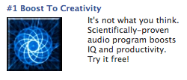
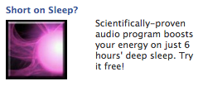

Targeting
UK, Canada, Singapore, Australia/NZ, South Africa traffic is cheaper than US traffic.

Use these keyword terms as a starting point for your own campaigns:

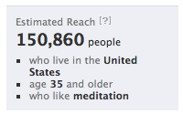 | 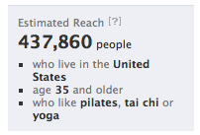
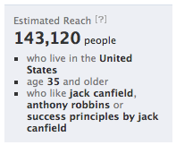 | 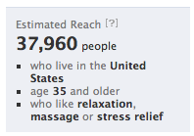
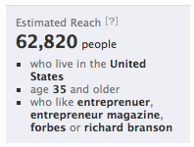 | 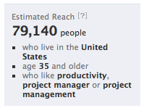

Images
The image is the most important element of the ad. A high contrast and colorful image -- red on white, red on yellow, a silhouette -- will attract eyeballs away from whatever else the traffic is looking at on the page.

Here are some images you can download from the Isochiral affiliate area:

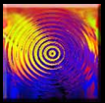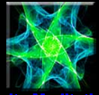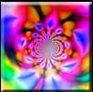

Gated Content

Increase your Likes by adding a content gateway, forcing traffic to Like your page to reveal your page content. See the next page for a very effective example of 'gating' content.

Here's a list of 10 popular apps you can use to gate your content:

http://www.socialmediaexaminer.com/top-10-facebook-apps-for-building-custom-pages-tabs/

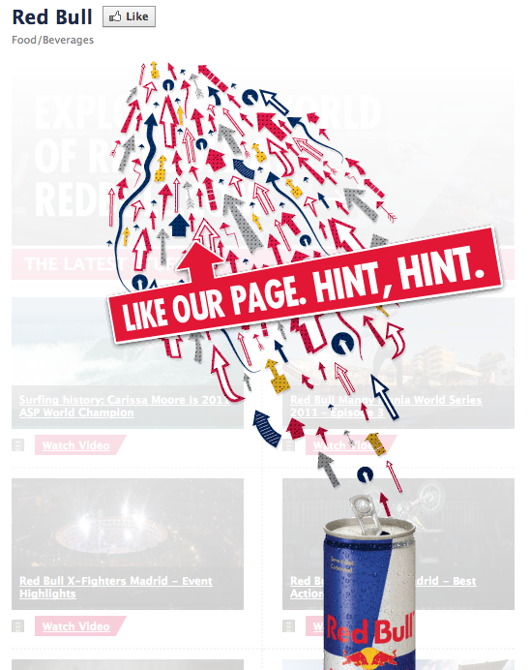

Good luck in promoting Isochiral on Facebook!

If you need any help at all, just get in touch with our affiliate team by mailing affiliates@Isochiral.com

Thank you for reading this mini guide!

